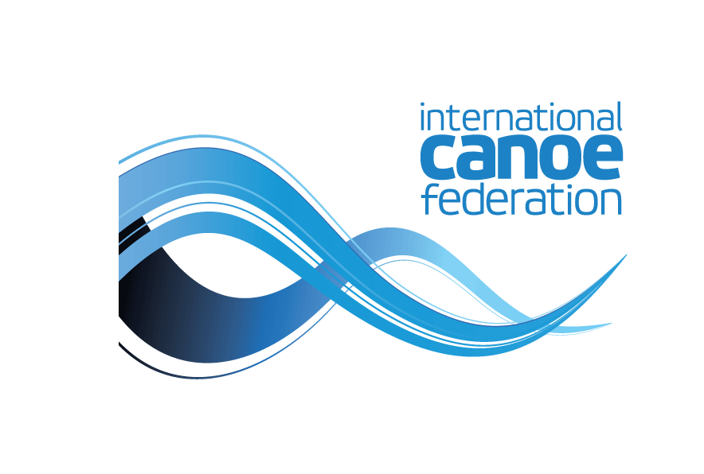

Distribution

° Members of ICF Board of Directors
Always moving forward

Agenda Board of Directors Meeting
Manchester, England – 24 -25 May 2017

Agenda Items

Meeting 9am

- Welcome by the President and British Canoeing
- President report
- Treasurer’s report
- Board of Directors individual Agenda items (File on ICF website)

- Bids for ICF Competitions – World Championships and World Cups

- Miscellaneous
- Next meeting

